Importing required libraries
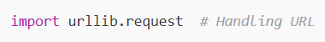
- Helps you open a website link and read its content.
- BeautifulSoup is used to extract text from HTML pages.
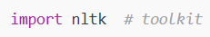
- NLTK = Natural Language Toolkit → used for text processing.
- Downloads common useless words like “the”, “is”, “and”.
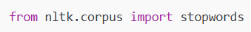
- Imports the stopwords list into your program.

2. Getting information from a website
- Opens the Wikipedia page for TATA.
- Wikipedia is rejecting the request because no User-Agent header is provided. Because the website thinks you are a normal browser. Wikipedia protects its server. When Python requests look like this:
User-Agent: Python-urllib/3.9. They block it as a bot → 403 Forbidden.
By adding:
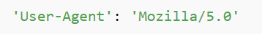
You look like Chrome browser → allowed.
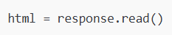
- Reads the full HTML content of the webpage.
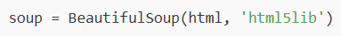
- Converts HTML into a structured format so we can extract text easily.
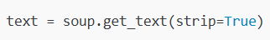
- Pulls all text from the webpage and removes extra spaces.
4. Tokenization (splitting into words)
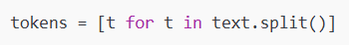
- Splits the text into individual words (tokens).
Example:
"Hello world" → ["Hello", "world"]

5. Removing stopwords
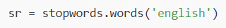
- Loads English stopwords (like “the”, “and”, “is”).
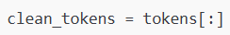
- Makes a copy of tokens to clean.
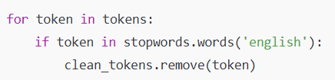
- Loops through each word.
- If the word is a stopword → remove it from clean_tokens.
Result:
Only meaningful words remain → no “the”, “is”, “and”, etc.

6. Frequency distribution of words
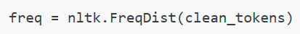
- Counts how many times each word appears.
Example:
{"TATA": 20, "company": 10, "India": 5}

7. Plotting the most common words
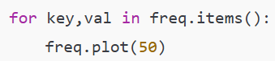
- Plots the top 50 most frequent words in a bar graph.
- Only the first iteration matters because the plot is called inside the loop → but graph shows only once.
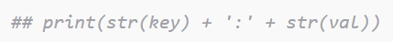
- (Commented) Would print each word and its count.

